SOFTWARE ENGINEERING - CSA0172

DAY 1 PROGRAMS ( 16 AUG 2023 )

PROBLEM 1 – ONLINE VOTING SYSTEM

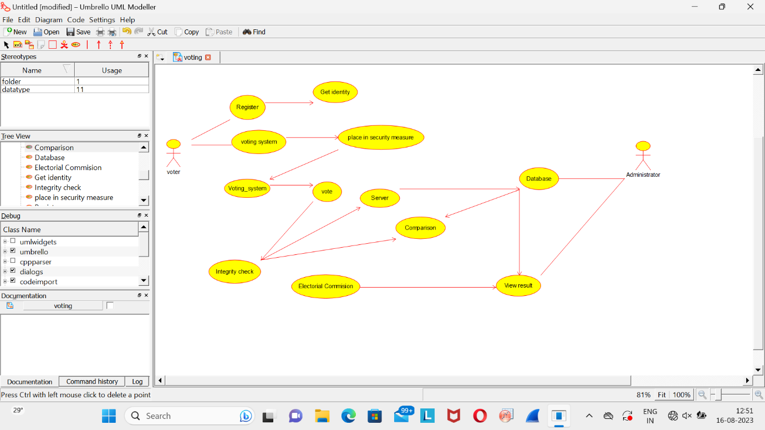

PROBLEM 2 – LIBRARY MANAGEMENT SYSTEM

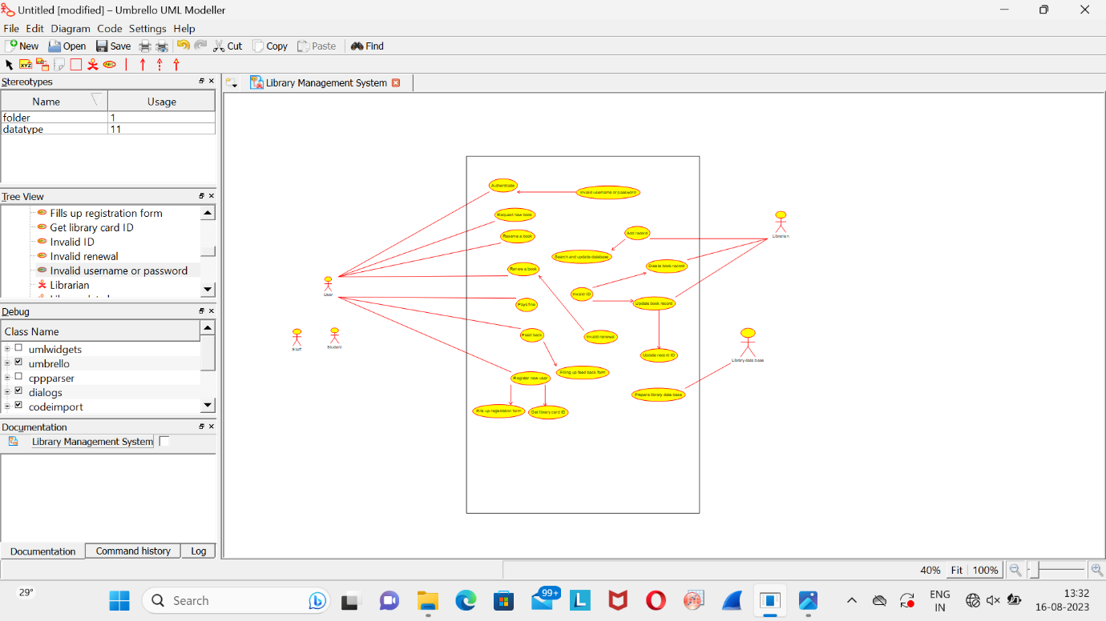

PROBLEM 5 – RAILWAY RESERVATION SYSTEM

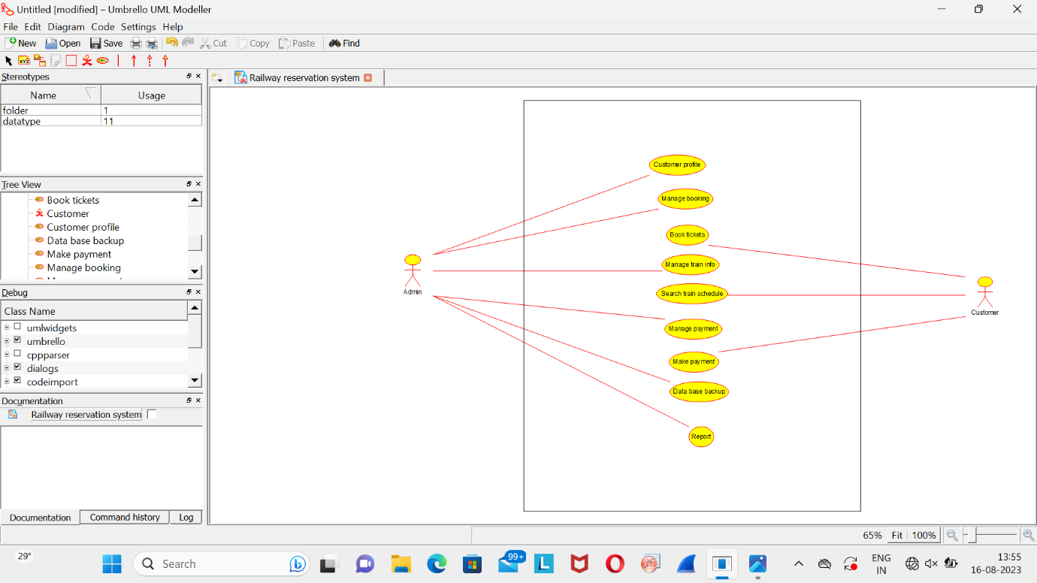

PROGRAM 6 – HOSPITAL MANAGEMENT SYSTEM

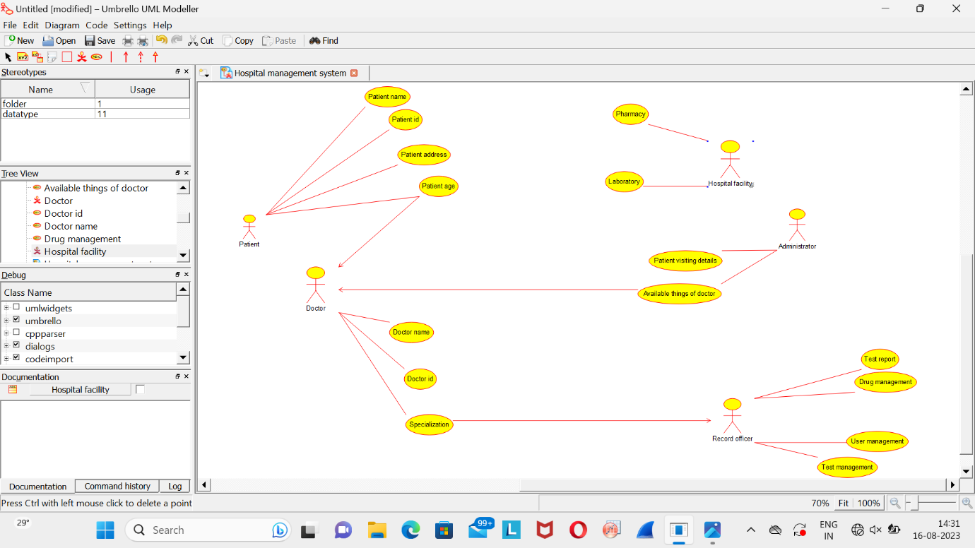

AIRLINE RESERVATION SYSTEM

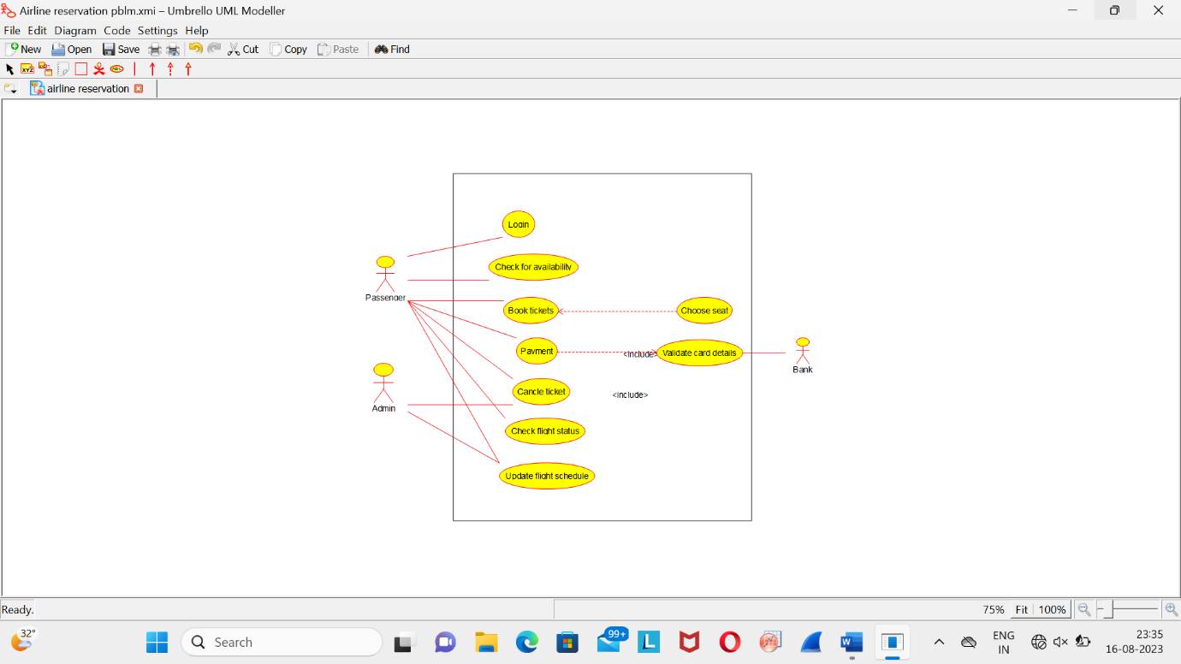

ONLINE COLLEGE MANAGEMENT SYSTEM

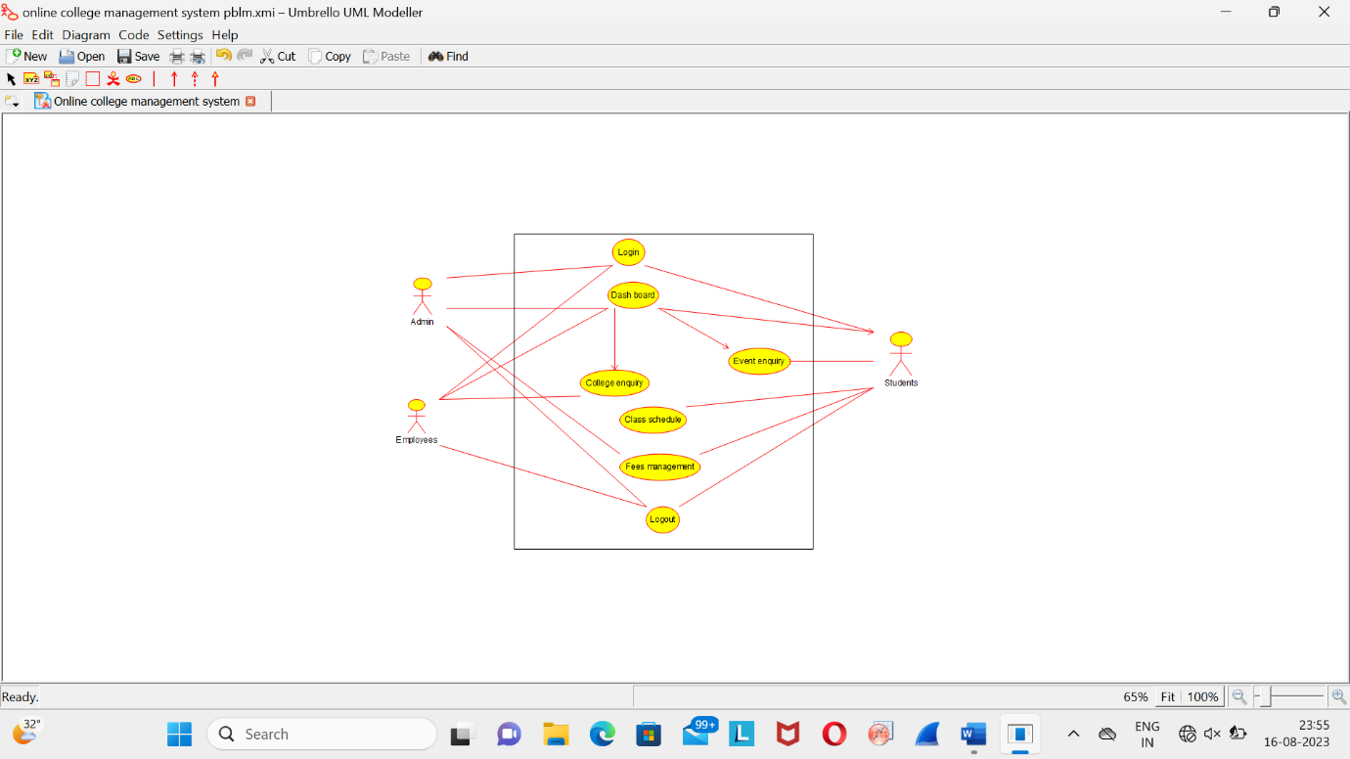

LIBRARY MANAGEMENT SYSTEM

